Tests done on tissue sample with ID: '15D47562' – Tissue 6

# Remove baseline

# Find ideal averaging area

# Average over space to reduce noise

## RUNNING AVERAGE

Spectra across row 100 after averaging (10-50pts):

Zooming in to columns 40-120 (peak)

## GAUSSIAN KERNEL – SIGMA = 10

## GAUSSIAN KERNEL – SIGMA = 1

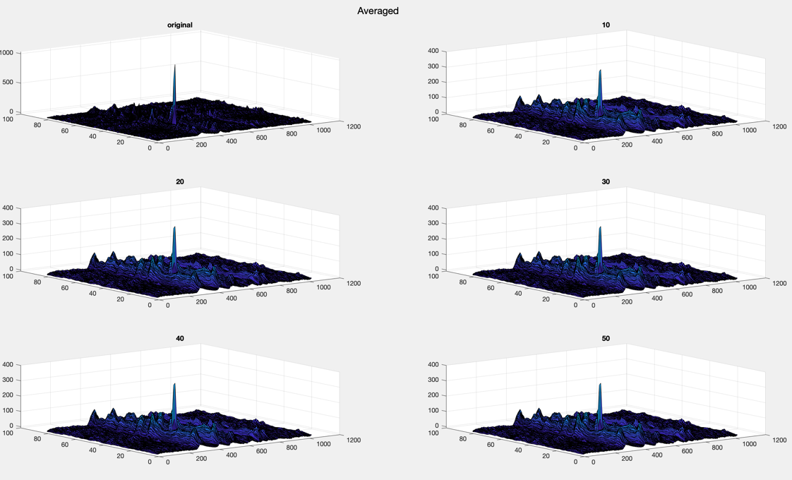

# Remove further noise

* Cosmic ray peaks
* If peak doesn’t appear in neighbours, ignore